Welcome!
Date
Name
Spouse
Address
City
State Zip _________
Email

Please Contact By
❑ Card  Phone  Visit

Telephone Best Time to Call
Home ______________
Work ______________

Guest: First Time Second Time
Are you a church member: yes no
Church
City, State

Circle Appropriate Age/Grade Group(s)
Preschool: Ages: B-1 2-3 4-5
Children: Grades: K 1 2 3 4 5 6
Youth: Grades: 7 8 9 10 11 12
Adults: Ages:18-29 30s 40s 50s 60s+

How did you learn about our church?
Newspaper Friend Yellow Pages Mail
Other

I am a guest of:

New in the Community? Yes No
Names & ages of children at home

Weekly Service & Activity Schedule

May 3, 2015
9:45 a.m. Sunday School
11:00 a.m. Morning Worship Service
6:00 p.m. Evening Worship

Week of May 3, 2015

Wednesday 7:00 p.m. Adult Prayer & Bible Study
Kids In Action is temporarily cancelled

Upcoming Events
May
10………………………………………………..Mother’s Day
10…………………………….Texas Baptist Hunger Offering
14………………………………….…………..Adult Fellowship
17….….….Independence Assoc. Music Festival (Brenham)

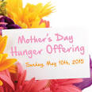
Give a special offering on Mother’s Day, May 10 as part of the Texas Baptist Hunger Offering.


If anyone is graduating this spring or summer, or if you graduated since the last time we had a Grad Banquet, please let Geneva Davis or Otisann McManus know. That includes high school, college, or trade school.

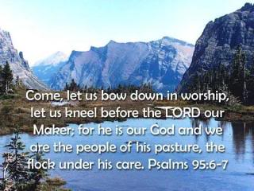

Knobbs Springs Baptist Church

May 3, 2015

Church Information:

KnobbsSpringsBC.com KnobbsSpringsBaptist@gmail.com
1662 CR 305, McDade, Texas 78650 512-273-2743
David Atwood, Pastor Cell 512-470-5098
Home 512-856-2819
Patti Radford, Office Manager Cell 512-968-7821

